**srkwrI hweI skUl qrmwlw**

**blwk: lMbI ijlHw:SRI mukqsr swihb**

[**ghs.tarmala.mks@punjabeducation.gov.in**](mailto:ghs.tarmala.mks@punjabeducation.gov.in) **+91-94631-08850**

|  |  |
| --- | --- |
| **v`loN**  **mu`K AiDAwpk**  **s.h.s. qrmwlw** | **v`l :**  **ij.is.A. (sY.is.)**  **SRI mukqsr swihb** |

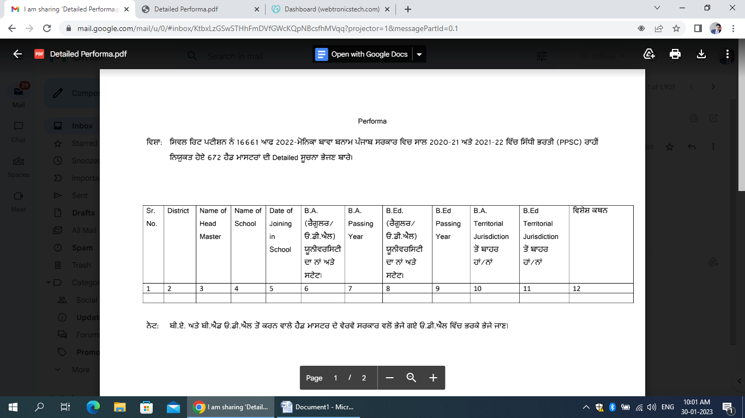**p`qr nM : 80 imqI : 30-01-2023**

|  |  |  |  |  |  |  |  |  |  |  |  |
| --- | --- | --- | --- | --- | --- | --- | --- | --- | --- | --- | --- |
| **Sr.**  **No.** | **District** | **Name of**  **Head**  **Master** | **Name of**  **School** | **Date of**  **Joining**  **in**  **School** | **B.A.**  **(rYgUlr/E.fI.AYl.)**  **XUnIvristI dw nW Aqy styt** | **B.A.**  **Passing**  **Year** | **B.Ed.**  **(rYgUlr/E.fI.AYl.)**  **XUnIvristI dw nW Aqy styt** | **B.Ed.**  **Passing**  **Year** | **B.A. Territorial Jurisdction**  **qoN bwhr hW / nW** | **B.Ed. Territorial Jurisdction**  **qoN bwhr hW / nW** | **ivSyS kQn** |
| **1** | **SRI MUKTSAR SAHIB** | **SRI AMANDEEP SINGH** | **GHS TARMALA** | **24-01-2020** | **REGULAR,**  **PUNJAB UNIVERSITY CHANDIGARH,**  **(D.A.V. College Abohar Distt Fazilka),**  **PUNJAB** | **2003** | **REGULAR,**  **PUNJAB UNIVERSITY CHANDIGARH,**  **(D.A.V. College Abohar Distt Fazilka),**  **PUNJAB** | **2004** | **nhIN jI** | **nhIN jI** |  |

